

Robert B. Aardema, Esquire
Aardema, Whitelaw & Sears-Ewald, PLLC
5360 Cascade Road
Grand Rapids, MI 49546

Re: Hurley v. Lakeland, et al
Invoice No. 132233

Dear Mr. Aardema:

This letter is being issued to you in regards to your past due account in the amount of $ 112.00 that is 50 days past due, in the above-referenced case. We have made numerous attempts to collect for services rendered. To date, we have not received payment. We pride ourselves in providing you with prompt delivery, and as a professional courtesy, we appreciate timely payment.
If you cannot make total payment within ten days, please contact our office to make payment arrangements. Enclosed you will find copies of the invoices.
We will anticipate payment by return mail. If you have any questions, please do not hesitate to contact me.
Sincerely,
Axiom Requisition Copy Service
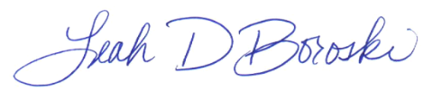

Leah D. Boroski
President

